

**OFFICE OF CATHOLIC SCHOOLS**

**MEMORANDUM**

**August 22, 2021**

Dear Parents and Guardians,

At this time, the Diocese of Palm Beach expects all students to comply with and adhere to the temporary facial covering requirements outlined in the August 20, 2021 memorandum. In the Diocese of Palm Beach, masks are required for all individuals while indoors in any buildings on our school campus and on school transportation. Masks are not required when students are outdoors and can practice social distancing. Families who submit a request through the process for a medical accommodation should follow the guidelines in the August 20 memorandum. While the medical accommodation application is in process and until the student receives approval, your child must wear a mask or facial covering when at school.

I take this opportunity to reiterate that this policy is the product of careful consideration and deliberation by the Diocese of Palm Beach as to what furthers the public good in the governance and administration of our Diocesan Catholic schools.

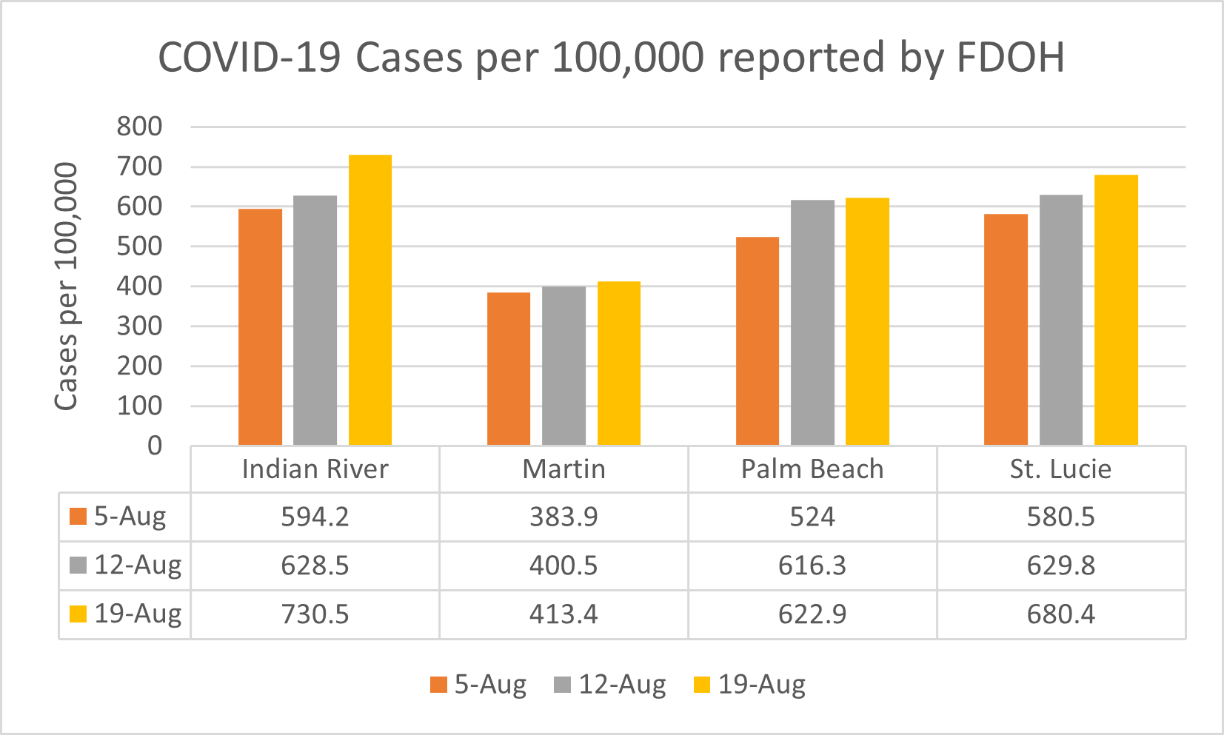We understand that some families strongly oppose the masks and some families are proponents of students wearing masks. We have received calls and emails on both sides of this issue. I offer this letter in response to those individuals as clarification for the questions that have been asked thus far. Unfortunately, the data released on August 19, 2021 by the Florida Department of Health indicates continued upward trends in the number of positive cases per 100,000 in each county. The peak is not expected for a few more weeks and we are looking for numbers of less then 100/100,000. New case positivity rates are also continuing to increase in our area.

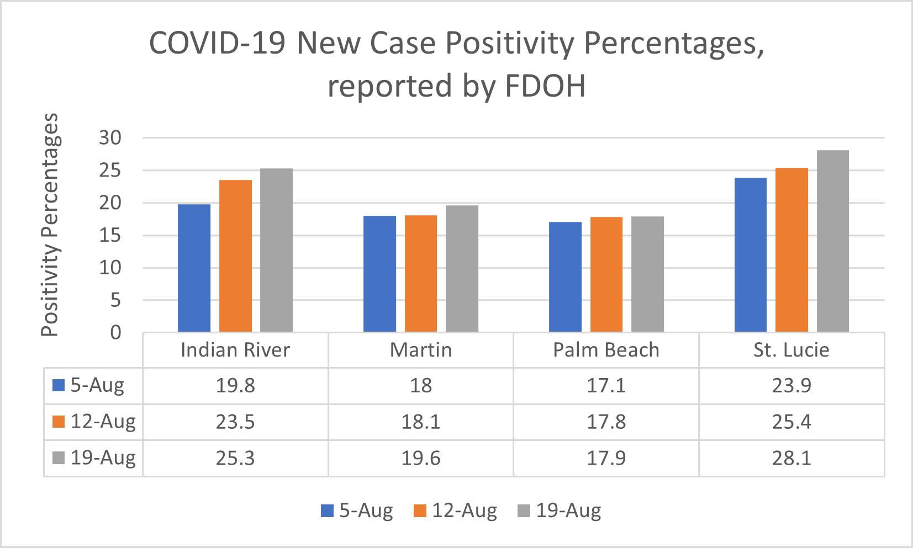

Should your child come to school without a mask, a mask will be given to your child and he/she will be expected to comply and wear the mask. If you or your child refuses, your child will be sent home. Your child will not be allowed to attend class without a mask. Families who fail to comply with these guidelines may be asked to consider other education options for their child.

It is our hope and expectation that students will comply with this temporary mask requirement for the next 60 days in the spirit of cooperation as agreed by you in the enrollment of your child.

Yours in Christ,

Gary Gelo

Gary Gelo

Superintendent of Schools